SIT314/SIT729 – Week 4 Group Activity
Designing Smart IoT Solutions

Overview

IoT applications often contain many parts, including data collection with sensors, data aggregation, filtering, storage, analysis, and eventually actuation in the environment such as switching a light on or turning a machine on. This activity is to think about a complex IoT application and design the IoT workflow for it.

Tasks
You should design the IoT flow for a `transport system for a smart city`.

When thinking about this, think about Sense-Think-Act.

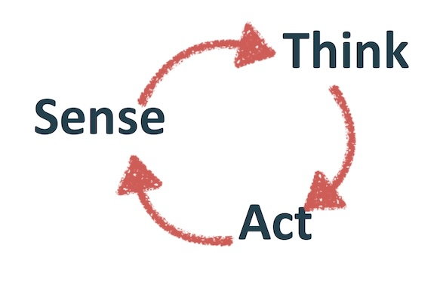

- Sketch a block diagram of the system.

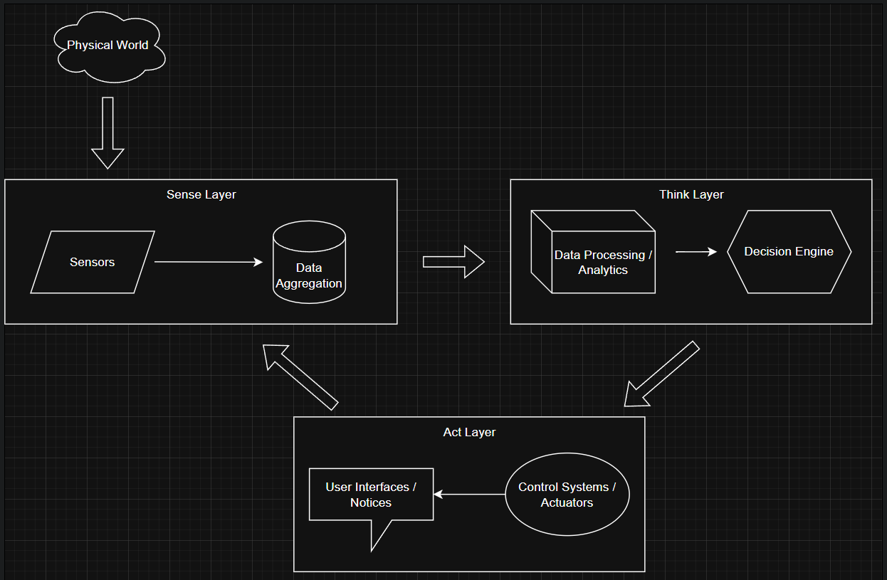

Key components:
- Physical layer: Vehicles, pedestrians, infrastructure
- Sensing layer: Cameras, GPS, speed sensors, occupancy detectors
- Network layer: MQTT brokers, gateways
- Processing layer: Traffic analysis, prediction models
- Application layer: Traffic control, navigation systems

- What are all the physical objects in the space (cars, people, traffic lights)?

- Vehicles: Cars, buses, trucks, bicycles, scooters, emergency vehicles

- Infrastructure: Traffic lights, streetlights, road signs, toll booths, parking meters

- People: Pedestrians, cyclists, traffic officers

- Public Transport: Trains, trams, buses, stations

- Road Elements: Lanes, intersections, crosswalks, bridges

- What is the data that is generated from sensors (car locations, traffic)?

- Vehicle Data: GPS location, speed, direction, acceleration, occupancy

- Traffic Flow: Vehicle counts, classification (car/truck/bus), queue lengths

- Environmental: Road conditions (wet/icy), visibility, temperature

- Pedestrian: Crosswalk counters, pedestrian density

- Public Transport: Bus/train locations, arrival times, passenger counts

- Infrastructure Status: Traffic light status, parking space availability

- What are the actuations of the system (traffic lights, car navigation, train speeds)?

- Traffic Control: Adjusting traffic light timing, dynamic lane assignment

- Navigation Systems: Rerouting suggestions to drivers/riders

- Public Transport: Adjusting train/bus frequencies and speeds

- Information Displays: Updating digital signage with traffic info

- Emergency Systems: Prioritizing emergency vehicle routes

- Parking Systems: Guiding drivers to available parking

- What are the processes and decisions that need to be made to connect the sensors to the actuators?

- Data Fusion: Combining data from multiple sources for accuracy

- Traffic Prediction: Using historical and real-time data to forecast congestion

- Priority Management: Emergency vehicle prioritization

- Load Balancing: Distributing traffic across alternative routes

- Anomaly Detection: Identifying accidents or unusual events

- Demand Response: Adjusting public transport based on demand

- Optimization Algorithms: Minimizing overall travel time

- Plan a hierarchical MQTT application-level communications protocol. Think about the identity of users and devices in the system and plan single-level or multi-level wildcards for message filtering.

- Topic Structure: smartcity/transport/[region]/[device_type]/[device_id]/[data_type]

- Example topics:

smartcity/transport/central/trafficlight/42/status

smartcity/transport/east/bus/571/location

smartcity/transport/north/parking/zone3/occupancy

- Wildcard Usage:

- Single-level (+): smartcity/transport/+/trafficlight/+/status

- Multi-level (#): smartcity/transport/central/#

- Device Identity Management:

- Each device has a unique ID and publishes to its specific topic

- Devices subscribe to relevant control topics

- Central systems use wildcards to monitor groups of devices

- Security Considerations:

- TLS encryption for all communications

- Device authentication using client certificates

- Fine-grained access control for topics

